**Week 10 Questions**

**Question 1**

1. P(X=0.5) = 0 since X is continuous
2. P(0.25 <= x <= 0.5) = P(x<0.5) – P(x<0.25)

= 0.5 – 0.25

= 0.25

1. P(-1 <= x <= 0.5) = P(x <= 0.5)

= 0.5

**Question 2**

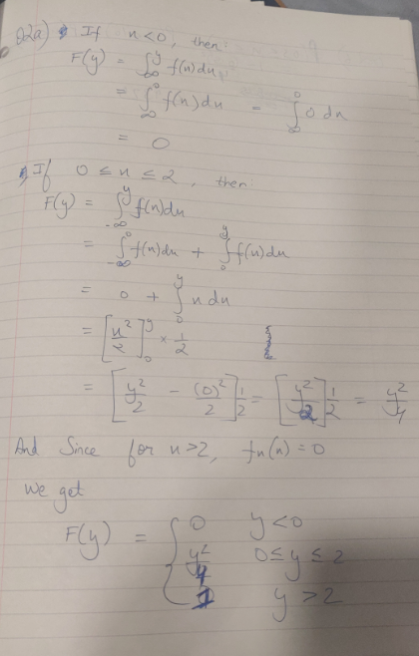

**Question 3**

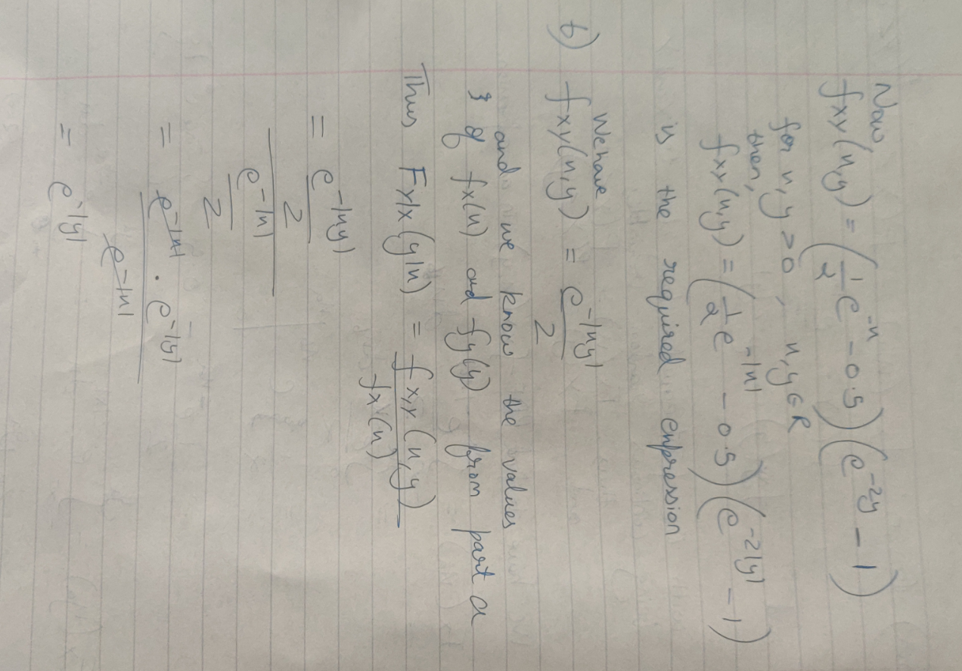

**Question 4**

1. The expression is :

1. The difference between gradient ascent and gradient descent is primarily that ascent is the process of maximizing while descent is the process of minimizing. Thus we take the loss function for gradient descent and multiply it by -1, we can then look for a maximum value. Then we can apply the same steps for the gradient ascent using the above function to obtain a value of (theta) which maximizes the PDF of training data.